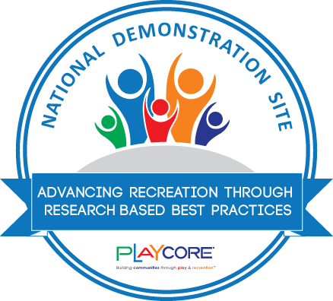

NDS Grand Opening Scripts
NOTE: Sales representatives are encouraged to be active at NDS opening events to help recognize their customers leadership and celebrate the impact the site will have on community vitality. Use the sample script below to highlight the facts of the designation and to encourage participation in the data collection. Take pictures and share them with CORE so we can include them in your customer’s reports and on the NDS map.

Hello! My name is (YOUR NAME), and I am the (ADD TITLE) for (AGENCY/BRAND). On behalf of (AGENCY NAME), (BRAND), and (BRAND’s) parent company, PlayCore, I want to thank (AGENCY/CUSTOMER NAME) for your outstanding commitment and leadership to play and recreation. We believe high-quality outdoor environments play a critical role in promoting community health and wellness. It was our honor to work closely with (AGENCY NAME), in the planning process and thoughtful implementation of an evidence-based design to support health and wellness initiatives in NAME OF CITY/COUNTY.
(PARK NAME) exemplifies an outdoor play and recreation destination that has thoughtfully turned research into practice to promote INCLUSIVE PLAY, PHYSICAL ACTIVITY, FITNESS, AND/OR CHILDREN’S ENGAGEMENT WITH NATURE (USE PER SPECIFIC SITE DESINATION/FOCUS AREA).
PlayCore’s Center for Outreach, Research & Education, also known as CORE, recognizes communities across North America as National Demonstration Sites. As a National Demonstration Site, you have successfully engaged stakeholders in the planning process, implemented evidence-based design principles within the built environment, provided ways to gather data about the site’s impact on the community, and ultimately enhanced the user experiences through unique programming opportunities.
I am thrilled to announce that, (NAME OF PARK) serves as a model project of excellence in the area(s) of
USE THE NDS DESIGNATION(S) THAT APPLY:
ADULT OUTDOOR FITNESS by thoughtfully aligning with evidence-based design best practices to promote physical activity and fitness. This Outdoor Adult Fitness Park offers a variety of aerobic, muscle/strength, core, balance, and flexibility equipment to provide a well-rounded fitness routine. Together, these elements can help individuals of all fitness levels engage in more moderate to vigorous physical activity, while enjoying the health benefits of physical activity.
INCLUSIVE PLAY by applying a comprehensive design philosophy by utilizing the 7 Principles of Inclusive Playground Design™ to innovate an outdoor play environment where both physical and social inclusion can occur to the greatest extent possible. Moving beyond minimum accessibility guidelines, this park intentionally addresses the development of the whole child, aligns with evidence-based design principles of the whole environment, and ultimately, benefits the whole community by providing a meaningful destination for individuals of all ages and abilities to play together. A robust and balanced assortment of playground activities can be found to support the physical, social-emotional, sensory, cognitive, and communicative needs of all children, including those with disabilities.
YOUTH PHYSICAL ACTIVITY by promoting fitness and fun by implementing the Play On! design best practices to intentionally promote physical activity through active play and encourage the developmental progression of skills through healthy movement. This outdoor play destination incorporates six key elements of play- balancing, brachiating, climbing, spinning, sliding, and swinging to promote fitness opportunities that support national physical education standards and efforts to combat childhood obesity.
NATURE PLAY by deliberately designing nature to create a unique destination through the integration of the living landscape with manufactured equipment to support play value, increase physical activity, foster social interaction, and improve environmental stability. By implementing NatureGrounds design best practices, this naturalized play environment offers rich opportunities for connecting children to nature and supports healthy human development across generations.
PLAYFUL PATHWAYS by intentionally infusing play along a walkable, shared-use linear environment to encourage active lifestyles for children, families, and their community. This Pathways for Play National Demonstration Site, creates a playful route for families to explore, discover, learn, and be physically active together surrounded by nature. This community destination was designed to promote environmental literacy by integrating play pockets along the pathway and educational signage to enhance learning and family fun.
PROVIDE DESIGNEE WITH AWARD
As a National Demonstration Site, CORE’s Data Service Lab will be working with (insert name of park department/customer) to provide outcomes data on this site’s contribution to overall Community Vitality. The CORE Data Service Lab’s Community Vitality Framework is an evidence-based perspective, grounded in comprehensive and validated research, that provides a unique approach to understand and implement the seven indicators of a vital community. It’s a powerful resource for validating the critical role you and this new site plays in overall community vitality. I encourage each of you to take a moment to share your experience today and contribute to this research. Simply scan the QR code found on the National Demonstration Site Recognition Signage located (direct them to the signage) to take a quick survey.
Congratulations- we are eager to continue to learn from your leadership and appreciate all you do to promote healthier, happier lifestyles through the power of play and recreation.
PHOTO OPPORTUNITIES (PLEASE TRY TO DOCUMENT AND SEND GRAND OPENING PHOTOS TO JENNIE SUMRELL AT JSUMRELL@PLAYCORE.COM
NOTE: After the ceremony, we highly suggest that you assist your customer in collecting user feedback through the NDS signage. Please help us by encouraging attendees to complete the user survey, a 10-question survey that provides valuable data to the organization to continue advocating for parks and recreation. Once the site reaches 50 surveys, PlayCore will generate a site-specific report for your customer. You may wish to bring an additional iPad to assist with this process, and we encourage you to stand near the sign to ask adults to participate. You can also use the following URL www.playcore.com/nds-reflecton-survey

